1. Create a folder called *learn_git*

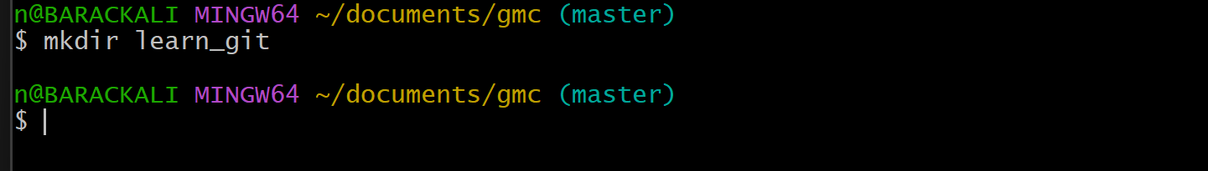

2. Change directory into *learn_git*

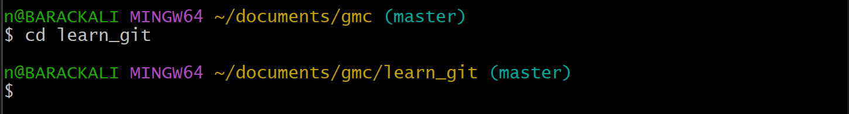

3. Create a file called *third.txt*

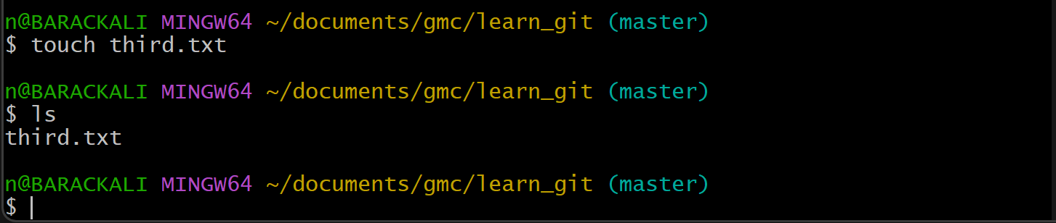

4. Initialize an empty Git repository

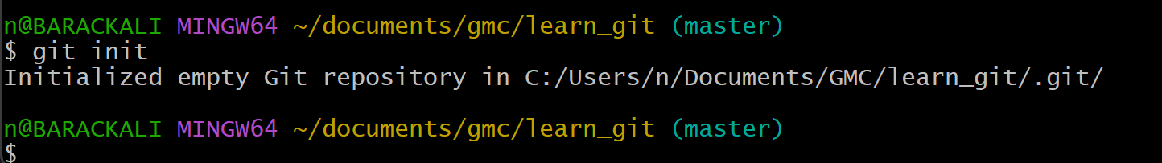

5. Add *third.txt* to the staging area

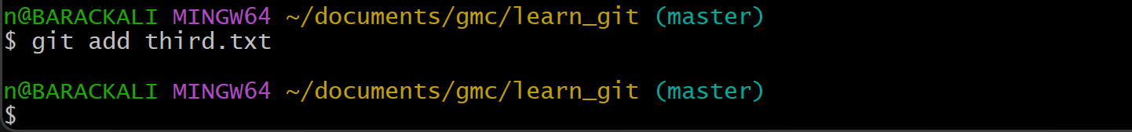

6. Commit with the message "adding third.txt"

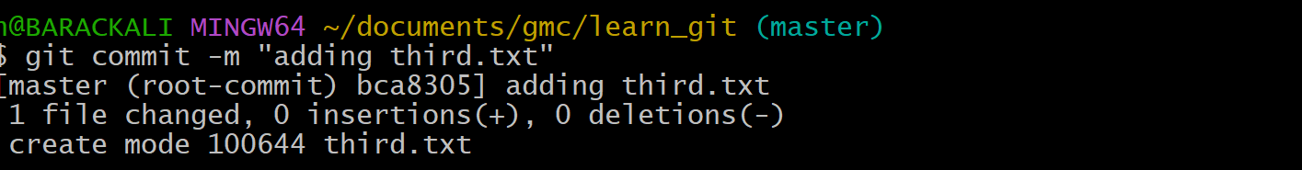

7. Check out your commit with *git log*

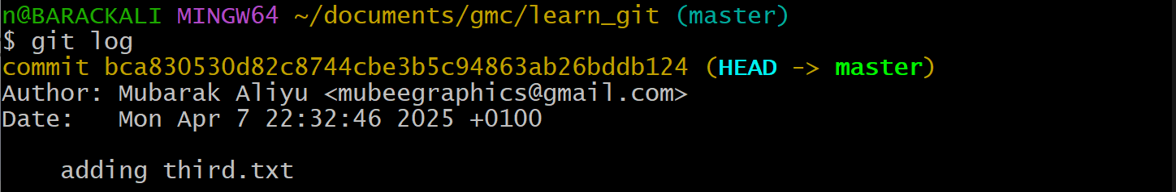

8. Create another file called *fourth.txt*

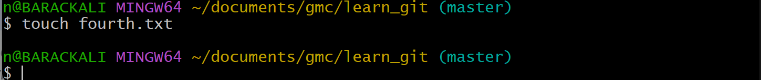

9. Add *fourth.txt* to the staging area

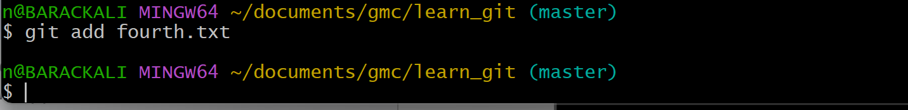

10. Commit with the message "adding fourth.txt"

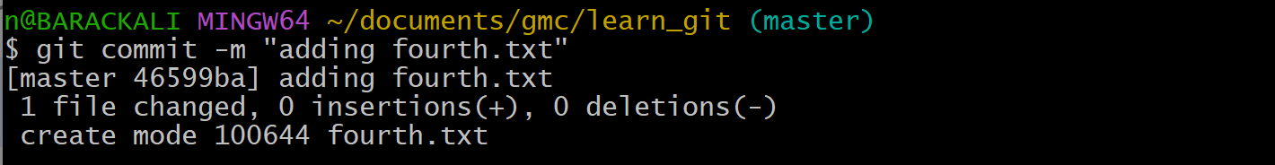

11. Remove the *third.txt* file

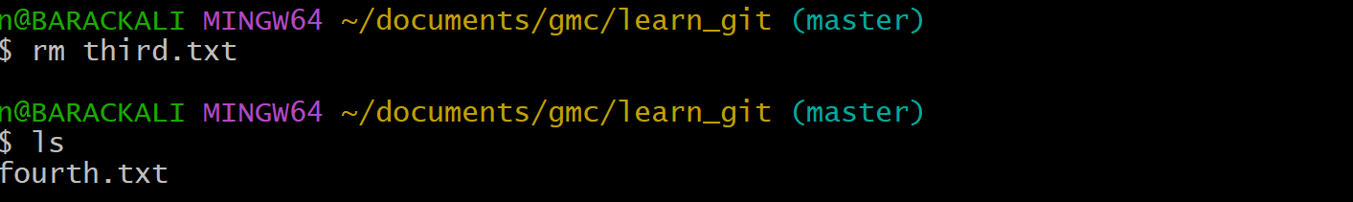

12. Add this change to the staging area



13. Commit with the message "removing third.txt"

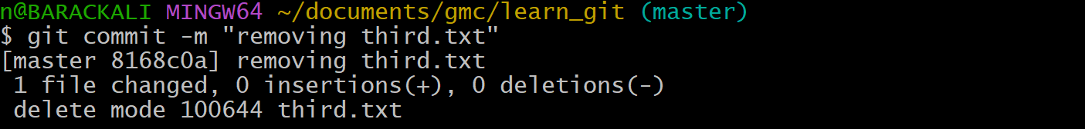

14. Check out your commits again with *git log*

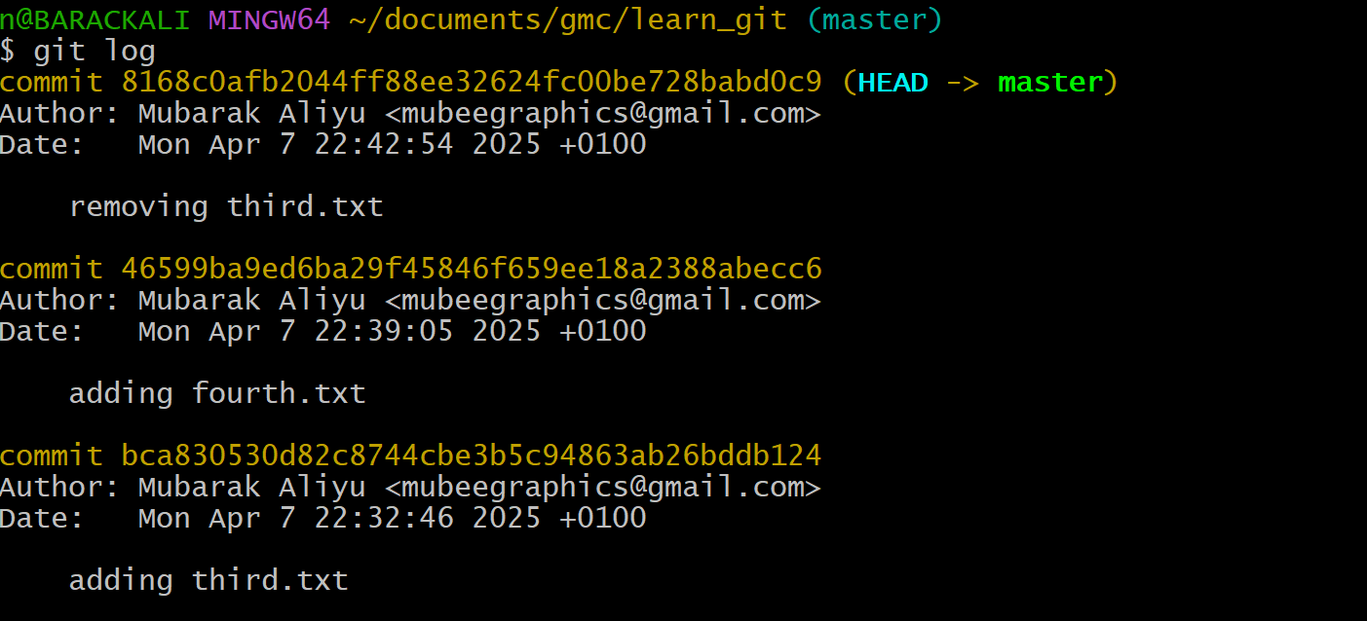

15. Change your global settings to *core.pager=cat*

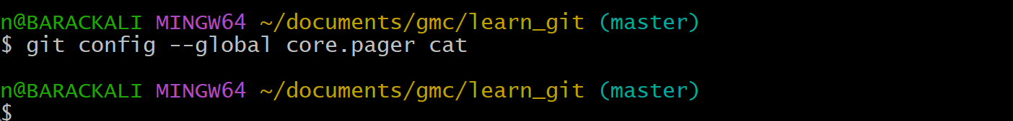

16. Write the appropriate command to list all the global configurations for git on your machine.

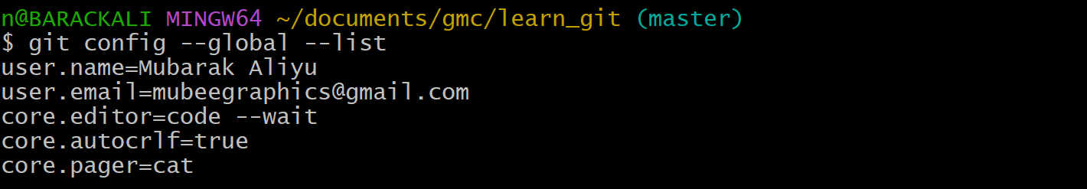

17. Push screenshots to GitHub

